2D CONVOLUTION OUTPUT
KANUKUNTLA LIKHITHA
254102409
EDGE DETECTION KERNAL
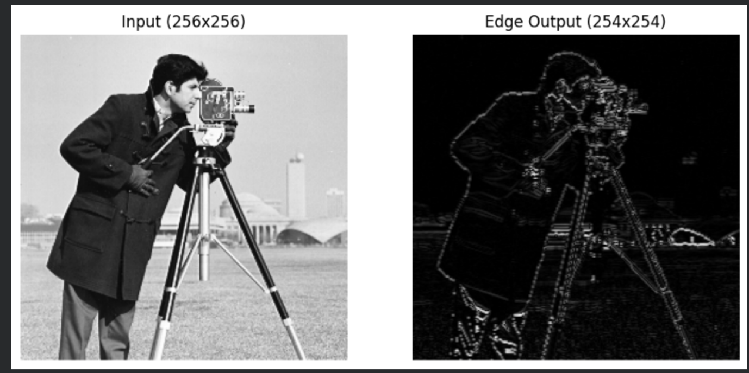
BLUR KERNAL
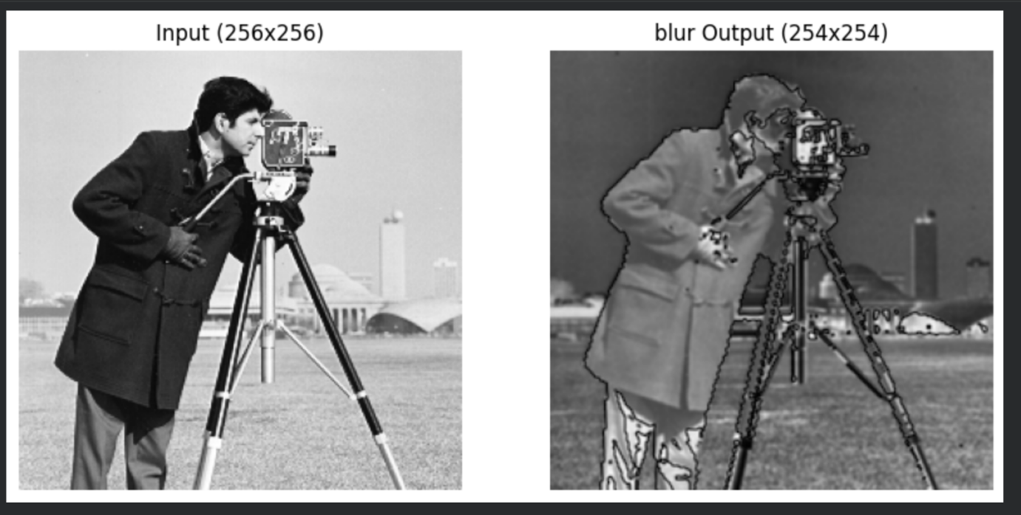

3D SHAWDOW LOOK FILTER
